- Write a program that will print your initials to standard output in letters that are nine (solution) lines tall. Each big letter should be made up of a bunch of *’s. For example, if your initials were “DJE”, then the output would look something like:
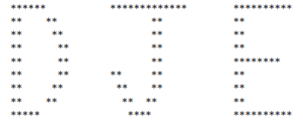
2. Write a C++ program to print 'Hello' on screen and then print your name on a separate line.
Expected Output:
Hello
Alexandra Abramov
3. Write a C++ program to print the following strings
Expected Output:
Tomorrow I 'll learn C++ Data types.
This is a bad command: del c:\*. *
4. Write programs called PrintPatternX.cpp (where X from A to D) to print EACH of the following patterns. Use one "cout <<" for each line of outputs. End each line by printing an "endl".
